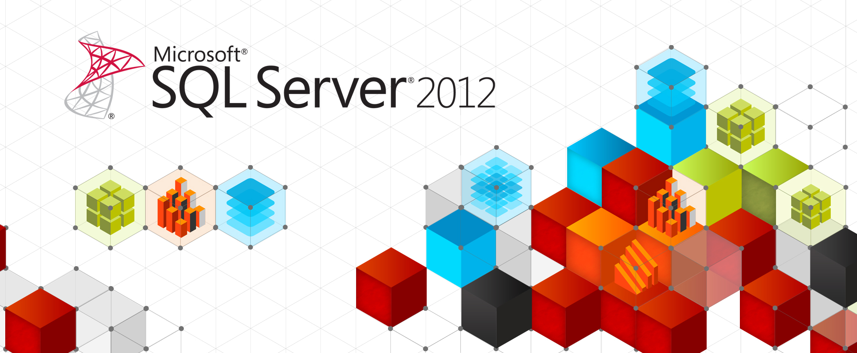
SQL Server 2012 Licensing Datasheet & FAQ
Published: March 7, 2012

Product Overview
SQL Server 2012 is a significant product release, providing Mission Critical Confidence with greater uptime, blazing-fast performance and enhanced security features for mission critical workloads; Breakthrough Insight with managed self-service data exploration and stunning interactive data visualization capabilities; Cloud On Your Terms by enabling the creation and extension of solutions across on-premises and public cloud. SQL Server 2012 is a Cloud Ready Information Platform.

Editions overview
The SQL Server 2012 Editions have been streamlined to better align with how customers are deploying applications and solutions. SQL Server 2012 will be released in 3 main editions*:
- Enterprise for mission critical applications and large scale data warehousing
- Business Intelligence, a new product edition, providing premium corporate and self-service BI
- Standard for basic database, reporting and analytics capabilities
The main editions are now offered in a consistent, tiered model which creates greater consistency across editions, features and licensing. Enterprise Edition will include all features available in SQL Server 2012. The Business Intelligence Edition will include premium BI features as well as all of the Standard Edition features.
*Note: SQL Server 2012 will continue to be available in Developer, Express and Compact editions. Web Edition will be offered in a Services Provider License Agreement (SPLA) model only. Datacenter Edition is being retired with all capabilities now available in Enterprise. Workgroup and Small business Editions are also being retired.

SQL Server 2012 Licensing Options
SQL Server 2012 will continue to offer two licensing options – one based on computing power, and one based on users or devices. In the computing power-based license model, however, the way we measure power will shift from processors to cores. Core-based licensing provides a more precise measure of computing power and a more consistent licensing metric regardless of where the solution is deployed across on-premises, virtual and cloud scenarios.
- Enterprise Edition (EE) will be licensed based on compute capacity measured in cores
- Business Intelligence (BI) Edition will be available in the Server + CAL model, based on users or devices
- Standard Edition (SE) offers both licensing models to address basic database workloads

 | SQL Server 2012 Editions |  | Description | Licensing Options |  | Pricing**
 |  |  | Description | Server  + CAL | Core Based | Open NL (US$)
 | Main Editions | Enterprise | High end datacenter, data warehousing and BI capabilities |  |  | $6,874 per Core
 | Main Editions | Business Intelligence | Enterprise BI and High Scale Analytics |  |  | $8,592 per Server*
 | Main Editions | Standard | Basic database and BI capabilities |  |  | $1,793 per Core, or $898 per Server*
 |  | Client Access License (CAL) | Access to SQL Server databases licensed per server |  |  | $209 per CAL
* Requires CALs, which are sold separately
**Pricing is for demonstrative uses only

Core-Based Licensing
- The Enterprise Edition and Standard Edition of SQL Server 2012 will both be available under core-based licensing. Core-based licenses will be sold in two-core packs.
- Core based licensing is appropriate when customers are unable to count users/devices, have Internet/Extranet facing workloads or systems that integrate with external facing workloads.
- To license a physical server, you must license all the cores in the server with a minimum of 4 core licenses required for each physical processor in the server.
- Core licenses will be priced at ¼ the cost of a SQL Server 2008 R2 (EE/SE) processor license.
- AMD systems have different requirements; see SQL Server 2012 Quick Reference Guide.

How to license
- License all of the physical cores on the hardware
- A minimum of 4 core licenses are required per physical processor
 | 
PHYSICAL  CORES IN THE  PROCESSOR: | 1 2 4 6 8
CORE LICENSES  REQUIRED | 4 4 4 6 8

Server and Client Access License (CAL) Licensing
- The Business Intelligence and Standard Editions will be available under the Server and Client Access License (CAL) model.
- This licensing model can be used when the number of users can be readily counted (e.g., internal database applications).
- To access a licensed SQL Server, each user must have a SQL Server CAL that is the same version or newer (for example, to access a SQL Server 2008 SE server, a user would need a SQL Server 2008 or 2012 CAL).
- Each SQL Server CAL can provide access to multiple licensed SQL Servers, including the new Business Intelligence Edition as well as Standard Edition Servers and legacy Enterprise Edition Servers.
- The SQL Server 2012 CAL price will increase by about 27%.
How to license
- License each individual server with a SQL Server license
- License each user or device accessing the server with a SQL Server CAL
SQL Server 2012 CALs can be used to access any SQL Server database licensed per server, regardless of platform or edition.
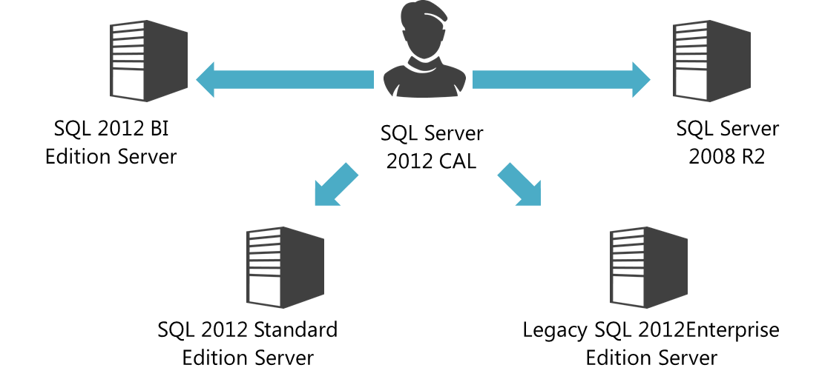

Virtualization Licensing - Cloud Optimized
SQL Server 2012 will offer expanded virtualization rights, options and benefits to provide greater flexibility for customers deploying in virtual environments. There will be two primary virtualization licensing options in SQL Server 2012: The ability to license individual virtual machines and the ability to license for maximum virtualization in highly virtualized and private cloud environments.

Individual Virtual Machines
- As hardware capabilities grow, it will become more common for each database to use a fraction of its server’s computing power.
- When deploying databases on Virtual Machines (VMs) that use just a fraction of a physical server, savings can be achieved by licensing individual VMs.
- To license a VM with core licenses, purchase a core license for each virtual core (virtual thread) allocated to the virtual machine (minimum of 4 core licenses per VM).
- To license a single VM with a server license (for Business Intelligence or Standard only), buy the server license and buy matching SQL Server CALs for each user.
- Each licensed VM covered with Software Assurance (SA) can be moved frequently within a server farm or to a third party hoster or cloud services provider without buying additional SQL Server licenses.
How to License VMs with Core Licenses
- License the virtual cores in each virtual machine
- There is a minimum of 4 core licenses required for each virtual machine
VM1 | VM2
 | 
VM with 4 Virtual Cores  4 Core licenses required | VM with 6 Virtual Cores  6 Core licenses required


How to License VMs with Server + CAL
- License each VM with a Server License
- License each user or device with a CAL

VM1 | VM2

VM with SQL Server Business Intelligence Edition  1 Server license required + CALs | VM with SQL Server Standard Edition  1 Server license required + CALs

High Density Virtualization
- Further savings can be achieved by operating a database server utility or SQL Server private cloud. This is a great option for customers who want to take advantage of the full computing power of their physical servers and have very dynamic provisioning and de-provisioning of virtual resources.
- Customers will be able to deploy an unlimited number of VM’s on the server and utilize the full capacity of the licensed hardware.
- They can do so by fully licensing the server (or server farm) with Enterprise Edition core licenses and Software Assurance based on the total number of physical cores on the servers. SA then enables the ability to run an unlimited number of virtual machines to handle dynamic workloads and fully utilize the hardware’s computing power.
- Customers cannot license for unlimited virtualization with SQL Server 2008 R2 EE Server + CAL. This was only a temporary use right grant with SA.

Licensing SQL Server private cloud:

- License all the physical cores on the server with Enterprise Edition core licenses and SA

- Deploy an unlimited number of VMs
Example

What you License  Physical Cores w/EE+SA |  | What you Deploy  Unlimited VMs (example 6)
Single Server, 2 physical processors, 6 cores/processor (12 total)    What to Buy:  12 SQL Server Enterprise Edition core licenses + SA | VM1
 | VM2
 | VM3
 | VM4
 | VM5
 | VM6

Transition to the New Licensing Models
In order to facilitate a smooth transition to the new editions and licensing, Microsoft is offering several options. These are designed to help enable customers to plan for the future while protecting their current investments.

Enterprise Edition Server + CAL Licensing
- New server licenses for SQL Server Enterprise Edition in the Server + Cal model will only be available for purchase through June 30th, 2012, after which they will no longer be available for purchase. EA/EAP customers that buy SQL Enterprise Edition Servers will have until their next EA/EAP renewal after June 30th, 2012 to purchase additional server licenses to complete currently planned projects. After that, all new SQL Server Enterprise Edition deployments must be purchased per core.
- All existing SQL Server Enterprise Edition licenses under the Server + CAL model with Software Assurance current when SQL Server 2012 launches can be upgraded to SQL Server 2012 at no additional cost, and SA can be maintained (in the server + cal model) to provide access to future software updates. These Legacy Enterprise Edition Servers remain licensed under the Server + CAL model and require the appropriate version of the SQL Server CAL for users or devices.
- Legacy SQL Server 2012 Enterprise Edition Server deployments licensed in the server + CAL model will be subject to a 20 core per server license maximum. This core maximum applies both to new server licenses and to prior version server licenses upgraded to 2012 with SA. If you purchased SQL Server 2008 R2 Enterprise Edition in the Server + CAL model with Software Assurance and at the launch of SQL Server 2012 are running on a server with > 20 physical cores, contact your Microsoft representative for help transitioning to the new licensing model.
- Legacy SQL Server 2012 Enterprise Edition Server licenses are still considered licensed under the Server + CAL model but have the new core limit to allow customers to upgrade their existing deployments and have some near term deployment options to finish currently planned projects under the Server + CAL model for the SQL Server Enterprise Edition.
- Moving forward, customers who would have purchased new EE server licenses can: purchase SQL BI server licenses for business intelligence, purchase SQL EE per core for high-scale database or data warehouse, or maintain legacy EE server licenses for existing projects requiring 20 cores or less.

SQL Server Processor licenses under SA moving to Core-based Licensing
- Customers with processor licenses under SA will receive rights to upgrade to SQL Server 2012 at no additional cost. At the subsequent renewal, the customer will have the opportunity to renew into core licenses.
- SQL Enterprise and Standard processor licenses under SA are valued at a minimum of 4 core licenses per processor or the actual number of cores in use. SQL Server Datacenter processor licenses are valued at a minimum of 8 EE core licenses per processor or the actual number of cores in use.
- At the end of the current agreement term, customers should do a self-inventory of systems currently running SQL Server, documenting the number of cores in each processor in use with a SQL Server processor license covered with Software Assurance. This will enable customers to receive the appropriate SQL Server 2012 use rights moving forward and will determine the core license exchange eligibility at renewal.
- Customers should do this self-inventory using the Microsoft Assessment and Planning (MAP) Toolkit or other inventory tools and processes to accurately archive a time/date stamped inventory of hardware tied to SQL Server installations.
- If customers do not perform the self-inventory, they will receive a value of 4 core licenses for each Standard and Enterprise Edition processor and 8 EE core licenses per Datacenter Edition processor.
 | 
PHYSICAL  CORES IN THE  PROCESSOR: | 2 4 6 8 10
RENEW ENTERPRISE OR STANDARD CORES: | 4 4 6 8 10
RENEW DATACENTER INTO ENTERPRISE CORES: | 8 8 8 8 10

License Transition Summary
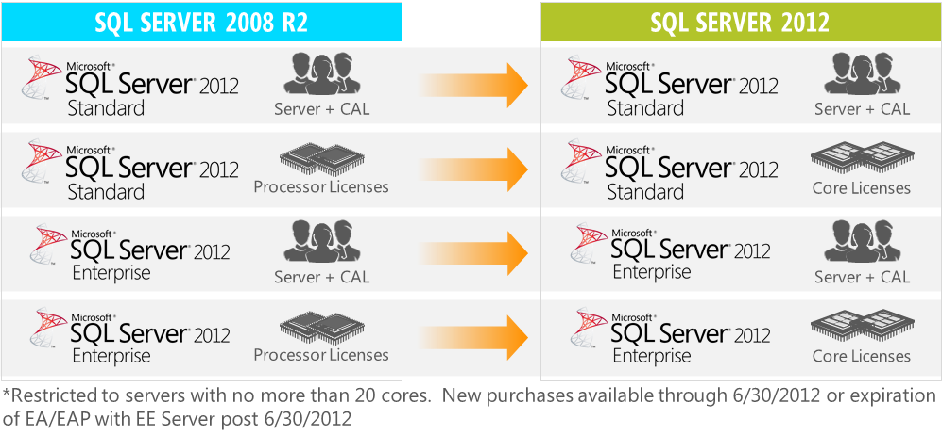

Customers with Enterprise Agreements
- Customers in existing Enterprise Agreements, EAPs and EASs will be able to continue to purchase processor licenses and Enterprise Edition server licenses through the end of their term.
- Customers purchasing processor licenses through the end of their term will continue to need to calculate the number of licenses required for a deployment based on the 2008 R2 processor use rights.
- Customers with an EA or EAP do have the option to add core licenses mid-term to their agreement for future purchases and should contact their reseller or Microsoft account team for more information.
- All servers licensed with SQL Server 2012 Enterprise Edition server + CAL licenses will be subject to the 20 core server limitation.
- The same process as outlined above will be followed at the end of term.

Planning for SQL Server 2012
Customers planning to deploy SQL Server 2012, either through upgrades or new licenses, should remember:
- Renewing Software Assurance (SA) is the best way to protect investments and provide access to new versions as well as Deployment Planning Services and technical assistance.
- EAP will continue to offer customers the best value, including discounts of up to 40% on new EE and BI server licenses.
- Customers should select the right edition depending on usage:
  - Enterprise for mission critical applications and large scale data warehousing
  - Business Intelligence for premium corporate and self-service BI
  - Standard for basic database, reporting and analytics capabilities
- Consolidation and virtualization are the best ways to maximize efficiency of hardware and control the size, computing power and more granularly manage cost of your deployments.

For additional information on Microsoft SQL Server 2012, go to the SQL Server website at: http://www.microsoft.com/sqlserver

This guide does not supersede or replace any of the legal documentation covering SQL Server 2012 product use rights. Specific product license terms are defined in the product Software License Terms—or in the case of Microsoft Volume Licensing—in the Microsoft Volume Licensing agreement under which the software was acquired and/or the Microsoft Volume Licensing Product Use Rights (PUR). This datasheet is not a legal use rights document. Program specifications and business rules are subject to change.

© 2012 Microsoft Corporation. All Rights Reserved.
This document is for informational purposes only. MICROSOFT MAKES NO WARRANTIES, EXPRESS OR IMPLIED, IN THIS SUMMARY.

Frequently Asked Questions
SQL Server 2012 – Editions and Licensing

Table of Contents

SQL Server 2012 Editions 3
1. What is new in SQL Server 2012? 3
2. Can you describe the product editions offered with SQL Server 2012? 3
3. What about other editions currently available in SQL Server 2008 R2 such as Datacenter, Workgroup and Standard for Small Business Editions? 3
4. What is the full list of editions that will be available with SQL Server 2012? 3
SQL Server 2012 Licensing 3
5. What are the key licensing changes with SQL Server 2012? 3
6. When will these changes come into effect? 4
7. Are there any virtualization or cloud-related licensing benefits with SQL Server 2012? 4
8. Could you explain why you are making these changes? 4
9. Will other Microsoft products move to core-based licensing as well? 4
10. Will the licensing changes be accompanied by an increase in pricing? 4
11. Can I buy core-based licensing for the Business Intelligence edition? 5
12. Can I use the same CAL for the Business Intelligence and Standard editions? 5
13. I have Software Assurance, do I have to pay more to upgrade to SQL Server 2012? 5
14. I recently signed up for an Enterprise Agreement (EA)/Enrollment for Application Platform (EAP). What do these changes mean for me? 5
15. How do I migrate from processor licenses to core licenses? What is the migration path? 5
16. How will SQL Server processor licenses with SA be exchanged for SQL Server 2012 core licenses? How will I (and Microsoft) determine the number of cores that I am owed? 5

SQL Server 2012 Editions

What is new in SQL Server 2012?
SQL Server 2012 will provide Mission Critical Confidence with greater uptime, blazing-fast performance and enhanced security for mission critical workloads; Breakthrough Insight with managed self-service data exploration and stunning interactive data visualizations capabilities; Cloud On Your Terms by enabling the creation and extension of solutions across on-premises and public cloud.

Can you describe the product editions offered with SQL Server 2012?
Three main editions, namely Enterprise, Business Intelligence and Standard, will be available:
- Enterprise for mission critical applications and data warehousing
- Business Intelligence (new) for premium corporate and self-service Business Intelligence capabilities
- Standard for basic database capabilities, reporting and analytics
The Business Intelligence edition will include all of the Standard Edition’s capabilities, and Enterprise will include all of the Business Intelligence Edition’s capabilities.

What about other editions currently available in SQL Server 2008 R2 such as Datacenter, Workgroup and Standard for Small Business Editions?
With the release of SQL Server 2012, the following three editions will be retired:
- Datacenter – its features will now be available in Enterprise Edition
- Workgroup – Standard will become our edition for basic database needs
- Standard for Small Business – Standard becomes our sole edition for basic database needs

What is the full list of editions that will be available with SQL Server 2012?
Enterprise, Business Intelligence and Standard will be our main editions. The Web Edition will be offered only to hosters via the Services Provider License Agreement (SLPA). Developer, Express and Compact Editions will also continue to be distributed without licensing or pricing changes. We also offer a range of appliances including Parallel Data Warehouse, a BI appliance, and a database consolidation appliance.

SQL Server 2012 Licensing

What are the key licensing changes with SQL Server 2012?
With SQL Server 2012, we will offer the following licensing options:
- Core-based Licensing for Enterprise
- Server + CAL licensing for Business Intelligence
- Choice of core-based licensing or Server + CAL licensing for Standard

When will these changes come into effect?
Licensing changes will come into effect at the general availability of SQL Server 2012. Microsoft SQL Server 2012 will release on April 1st, 2012.

Are there any virtualization or cloud-related licensing benefits with SQL Server 2012?
SQL Server 2012 will provide a variety of virtualization and cloud benefits that will help customers save money on database licensing and retain flexibility in their database deployments. Customers can:
- License individual Virtual Machines (VM), and when licensing per core, buy core licenses only for the virtual cores (threads or physical cores) assigned to the VM.
- License for high VM density by buying EE core licenses and Software Assurance (SA) for all the physical cores on the server (or server farm) and deploying any number of VMs on the licensed hardware. Without SA, VM density is limited to one VM per core with EE.
- License for VM mobility across private and public clouds. VM license mobility is an SA benefit. Without SA, licenses can be moved from one server to another only once every 90 days.

Could you explain why you are making these changes?
The changes to SQL Server licensing reflect the evolution of the database industry along with new hardware deployment practices. Internal customer research with hundreds of customers has shown us that database customers are comfortable with core-based licensing and consider licensing by core simple and predictable. There is also great enthusiasm for our virtualization and cloud-friendly licensing to help customers save money as their deployment practices evolve. With these changes, we will continue to offer industry leading TCO.

Will other Microsoft products move to core-based licensing as well?
We have put in place licensing models that are appropriate for the products based on industry and customer needs. The changes to SQL Server licensing are based on trends in the database industry and were developed with just the database business in mind.

Will the licensing changes be accompanied by an increase in pricing?
With SQL Server 2012, we are delivering a more powerful Enterprise Edition and a new Business Intelligence Edition with innovative features. SQL Server customers who benefit from the new capabilities and who deploy mission critical databases will likely pay more, though we will continue to be the industry TCO leader.
At the same time, we are offering licensing benefits and flexibility to help customers save money and control costs with virtualization and consolidation. The net price impact to individual customers will vary based on how they deploy SQL Server 2012, their current capacity and their future needs.
We have been actively engaged in conversations directly with our customers and partners to ensure that they know how these changes may impact them.

Can I buy core-based licensing for the Business Intelligence edition?
Enterprise Edition includes the full capabilities of SQL Server 2012, so a customer who wants to license a BI Server on a per core basis can do so by buying Enterprise Edition. Enterprise Edition will be the preferred way to license advanced SQL Server BI capabilities when users are uncountable (e.g., external facing workloads) or when there is a very large number of users.

Can I use the same CAL for the Business Intelligence and Standard editions?
Yes, as with prior releases, there is a single CAL for SQL Server 2012 for access to all the server editions.

I have Software Assurance, do I have to pay more to upgrade to SQL Server 2012?
No. All licenses under SA will be able to upgrade to SQL Server 2012 at no additional cost.

I recently signed up for an Enterprise Agreement (EA)/Enrollment for Application Platform (EAP). What do these changes mean for me?
EA and EAP remain the best ways for customers to license SQL Server. EA and EAP offer extended transitions to help you plan for the new licensing model. Furthermore, EAP offers significant discounts to help you take advantage of the lowest TCO.

How do I migrate from processor licenses to core licenses? What is the migration path?
Licenses purchased with Software Assurance (SA) will upgrade to SQL Server 2012 at no additional cost. EA/EAP customers can continue buying processor licenses until your next renewal after April 1st, 2012. At the next renewal, processor licenses will be eligible to be renewed into core-based licenses sufficient to cover the cores in use by the processor-licensed databases (minimum of 4 cores per processor for Standard and Enterprise, and minimum of 8 Enterprise cores per processor for Datacenter).

How will SQL Server processor licenses with SA be exchanged for SQL Server 2012 core licenses? How will I (and Microsoft) determine the number of cores that I am owed?
You can perform a “self-inventory” of your environment at the end of your Software Assurance (SA) term that will provide the basis for your long term SQL Server 2012 use rights and eligibility for renewal into core licenses. We will provide access to the Microsoft Assessment and Planning (MAP) Toolkit as one way to help track and document deployments. This tool can help you plan the transition from processor-based licenses to core-based licenses by counting both processors and cores across your deployments. If you are not able to document your SQL Server deployments, then your processors will be worth the standard conversion ratio by edition. We encourage you to work with your Microsoft or Partner representative to determine an optimal transition plan.

